Spotify API

Unfortunately spotify doesn’t support in Bangladesh but let see how their api work

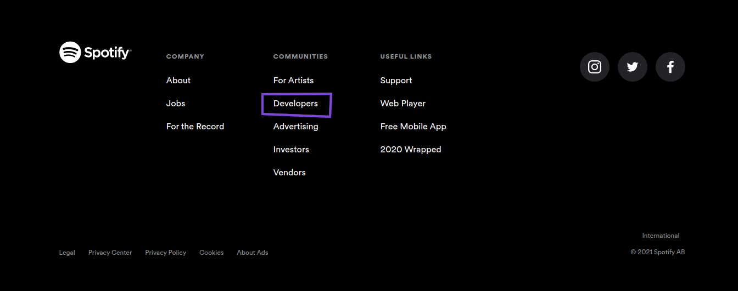
Al most in every website which provide api has a section call developer → go there to find out api and all the possibilities for a developer.

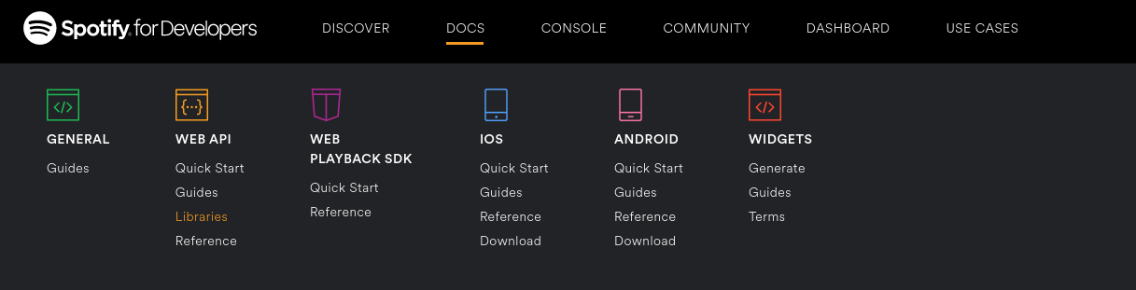
In docs section → there has some efferent way where we can use the api

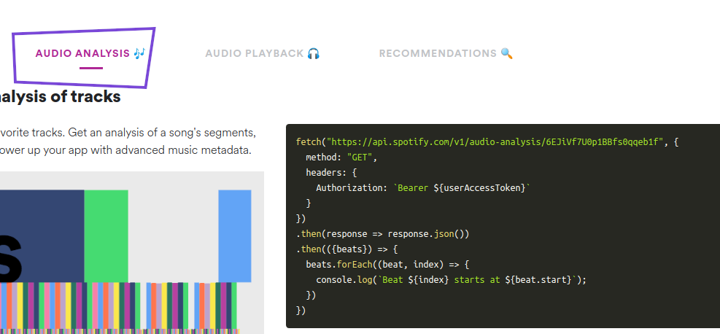
Here they have given the example api request using fetch

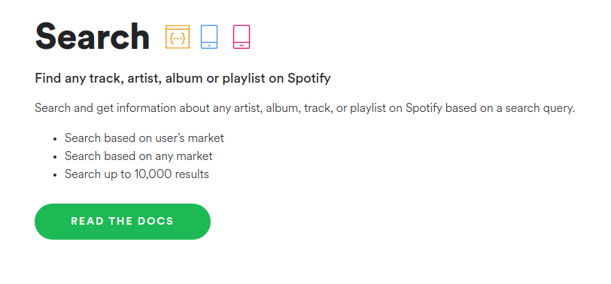

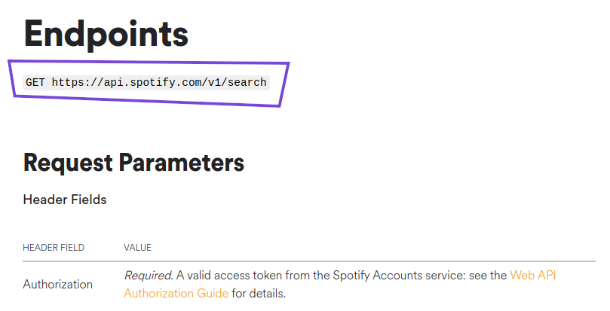
They specified api endpoint where we have to sent request, Every website look for it.

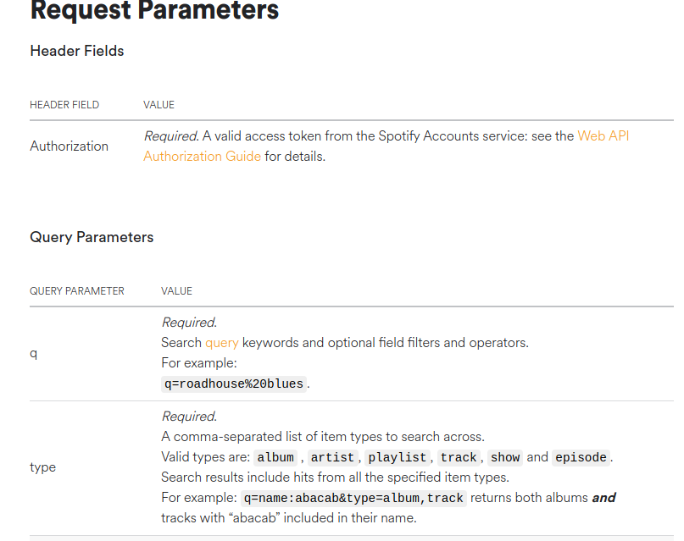

Check request parameters and query parameters properly

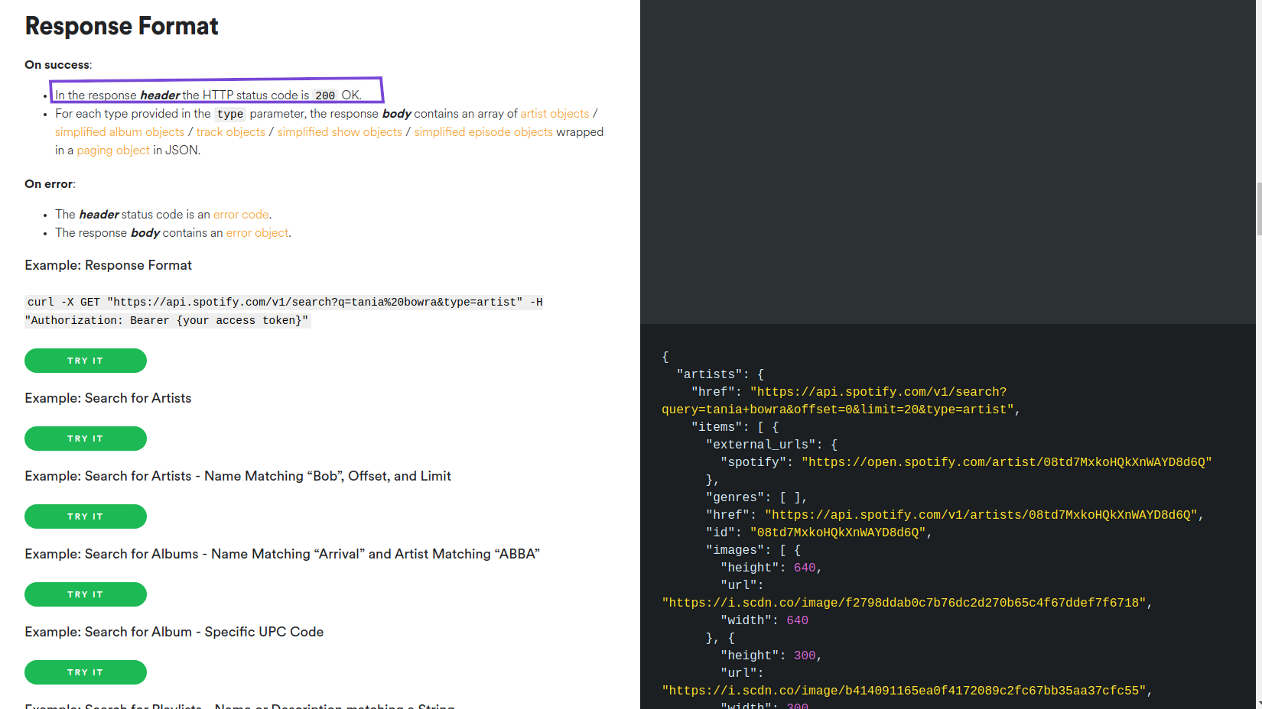

This is the response format what we will get back. And very impotently look for status code and response header

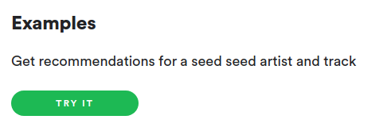
We can work with their api in their website console

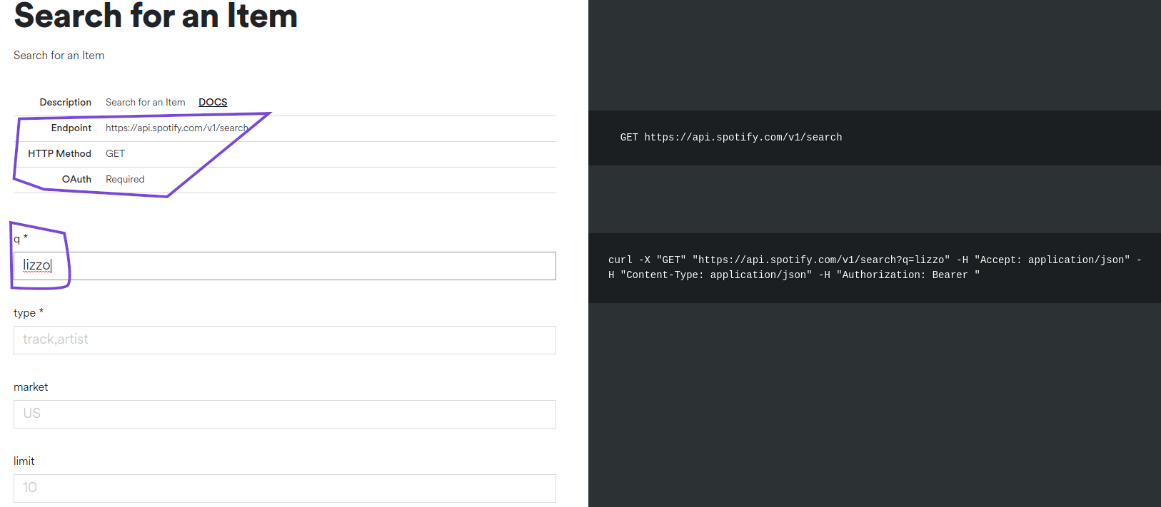
Here they are asking for query by which we will search, On right we have curl setup for making requests

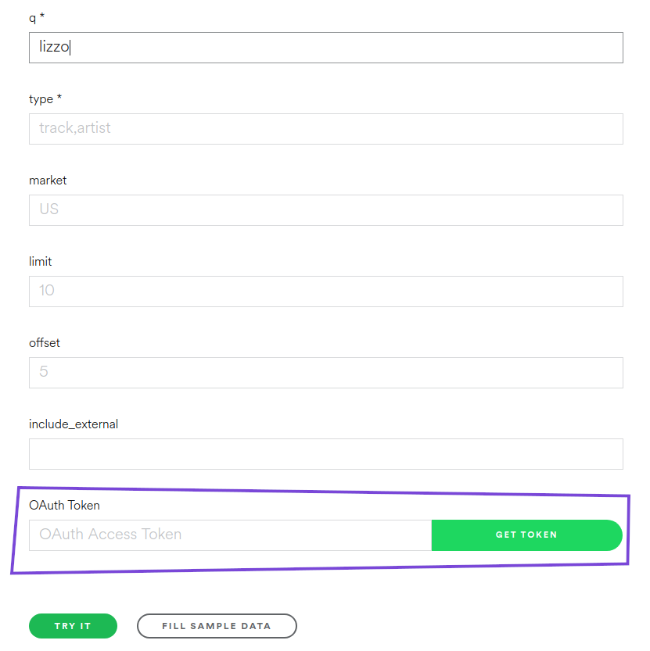

We need access token to search → get token → sign up → and make requests

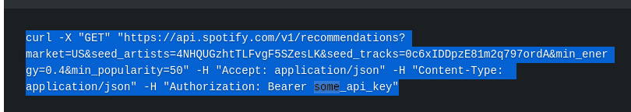
Here is our api request using curl and it has api key → since spottily is banned in bd so I used random api → it will give us an error message

